**Uncertainty**

Uncertainty in AI,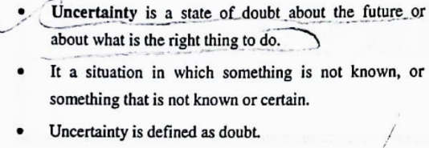

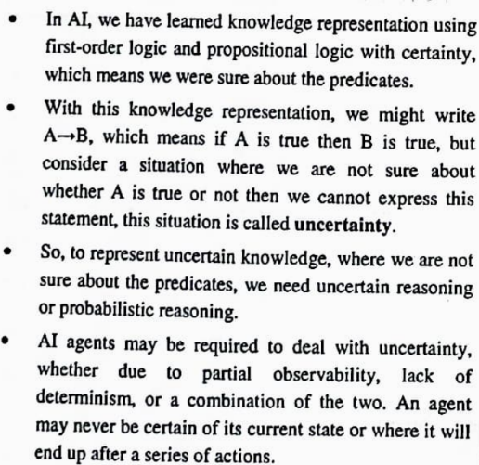

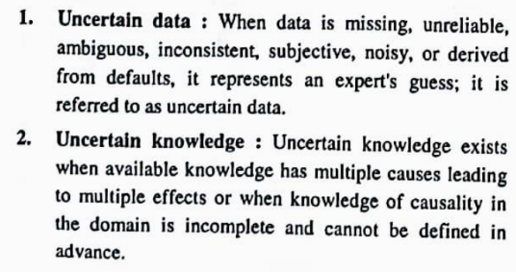

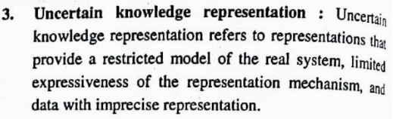

Inference using full joint distributions,

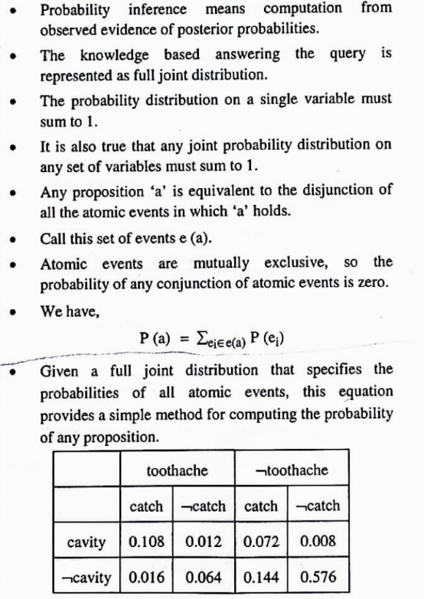

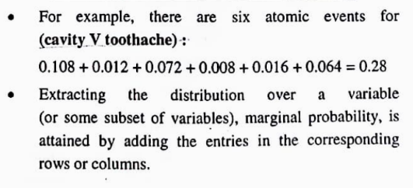

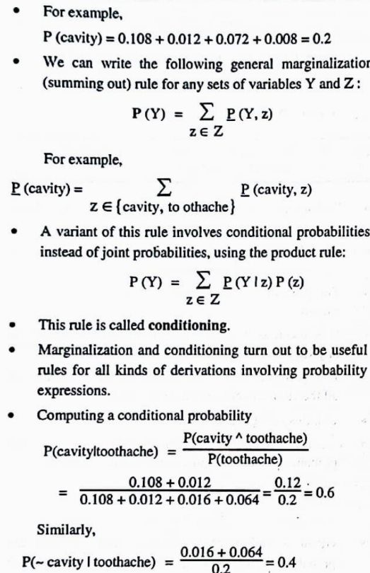

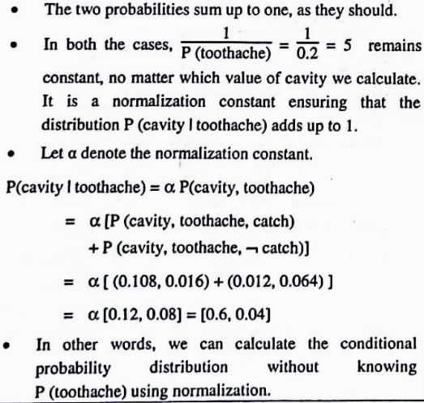

Bayes Theorem,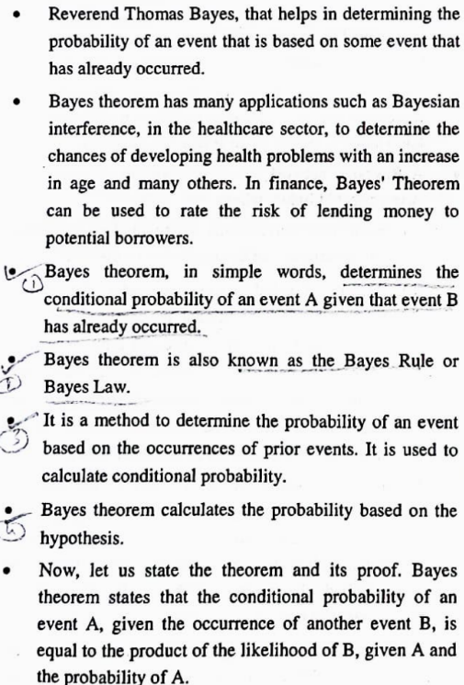



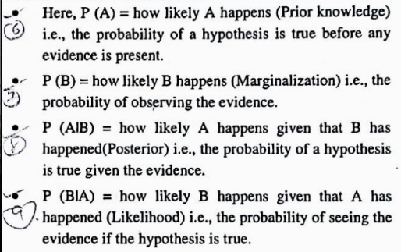

the semantics of Bayesian Networks,

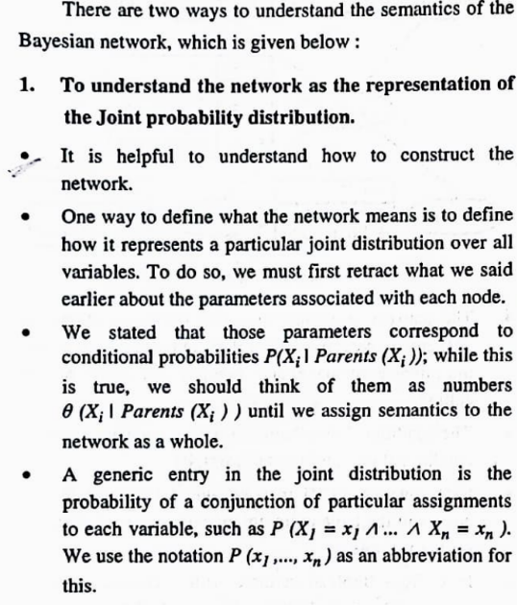

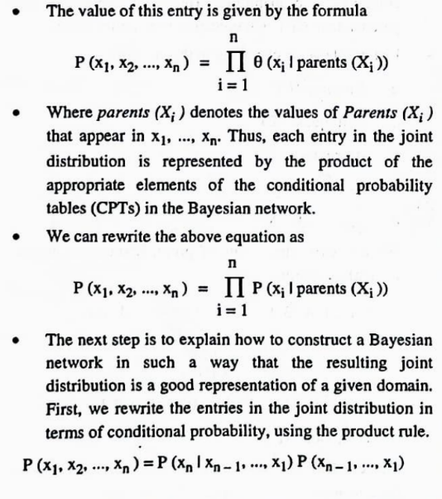

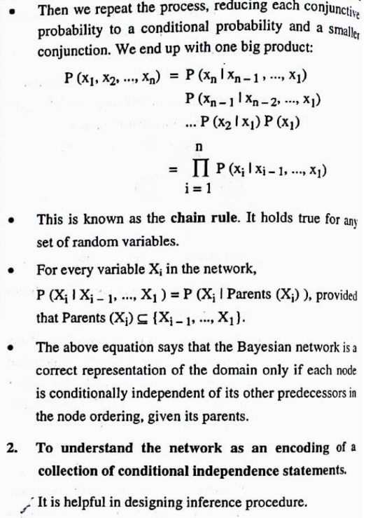

Inference in Bayesian networks, Decision Theory, Markov

Decision Processes.

Self-learning Topics: Hidden Markov Model (HMM),

Gaussian Mixture Model (GMM)

Explain the Bayesian belief network using a suitable example and its advantages and applications.

Short note on Markov Decision Processes.

**Cognitive**

**Computing**

Foundation of Cognitive Computing, Design Principles for

Cognitive Systems, Natural Language Processing in Support of

a Cognitive System, Representing Knowledge in Taxonomies

and Ontologies,

Applying Advanced Analytics to Cognitive

Computing, The Process of Building a Cognitive Application.

Self-learning Topics: Cognitive Systems such as IBM’s

Watson.

How can we represent knowledge in taxonomies and ontologies in the Cognitive system?

State is the condition of a system at a particular point in time or in a specific situation.

**Fuzzy Logic**

**& Its**

**Applications**

Introduction to Fuzzy Sets, Properties of Fuzzy Sets,

Operations on Fuzzy Sets, Fuzzy Membership Functions,

Fuzzy Relations with Operations and its Properties,

Fuzzy Composition: Max-Min Composition, Max-Product

Composition, Defuzzification Methods, Architecture of

Mamdani Type Fuzzy Control System,

Design of Fuzzy Controllers like Domestic Shower Controller, Washing

Machine Controller, Water Purifier Controller, etc.

Self-learning Topics: Other Fuzzy Composition Operations,

Fuzzy Inference System (FIS) & ANFIS.

Explain the steps in the Fuzzy Inference System.

Explain different operations on fuzzy set.

Explain the Max-Min and Max-Product Composition relation with a suitable example.

Design a Fuzzy Logic Controller System for the microwave oven, intelligent air conditioning system.

***IMP Questions Modulewise***

**Module 1**

1. Sources of Uncertainty

2. Probability Terminology

3. Bayes Rule & Theorem

4. Joint Probability (Distribution)

5. Semantics of Bayesian Network

6. Bayesian Network (5M) / Bayesian Belief Network (Same hi hai na dono ek baar check karo)

7. Inference in Bayesian Network (Short note).

8. Monte Carlo method (2m)

9. Decision theory (Short Note) (5m)

10. Markov decision process (Short note) (5m)

11. Inference using full joint distribution (2m)

12. Hidden markov (Explanation not imp)

**Module 2**

1. Cognitive computing

2. Foundation of cognitive computing technologies,

Applications,

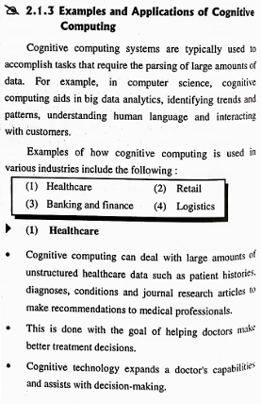

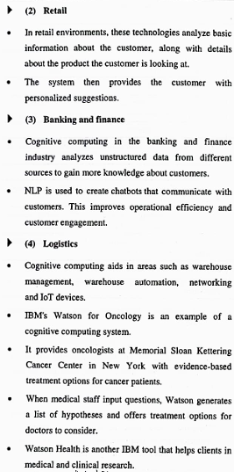

Features

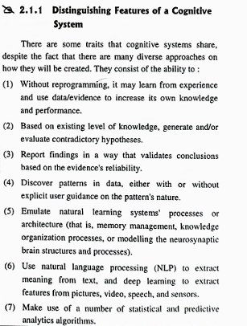

3. adv. Disadvantages

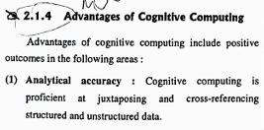

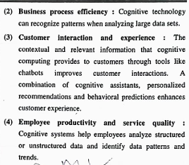

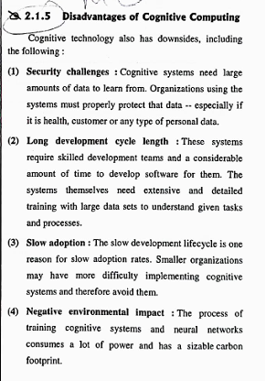

4. Comparison cognitive computing vs AI

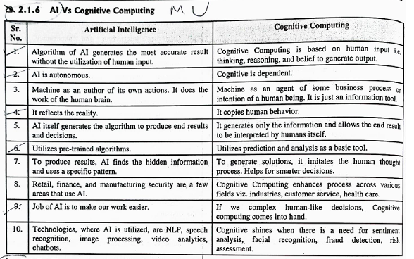

5. elements of cognitive system (same diagram for design principles)

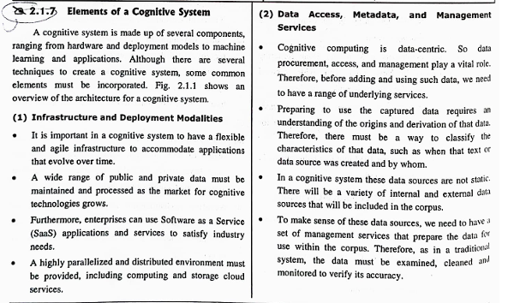

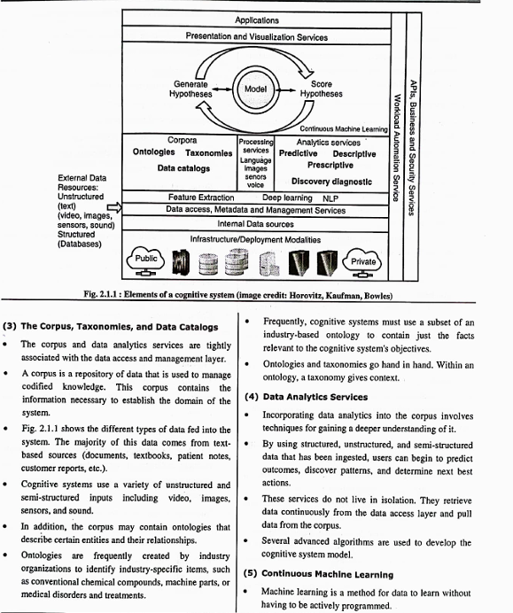

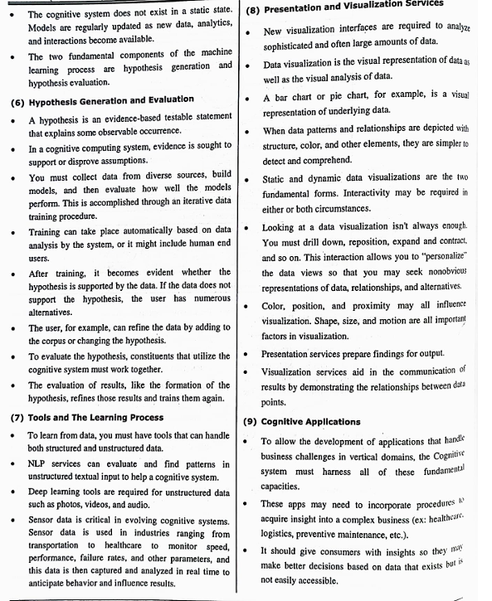

6. Design principles of cognitive system

7. Role of NLP in cognitive systems.

8. Morphology & Taxonomy

9. Advanced analytics

**Module 3**

**1. Fuzzy set definition and representation**

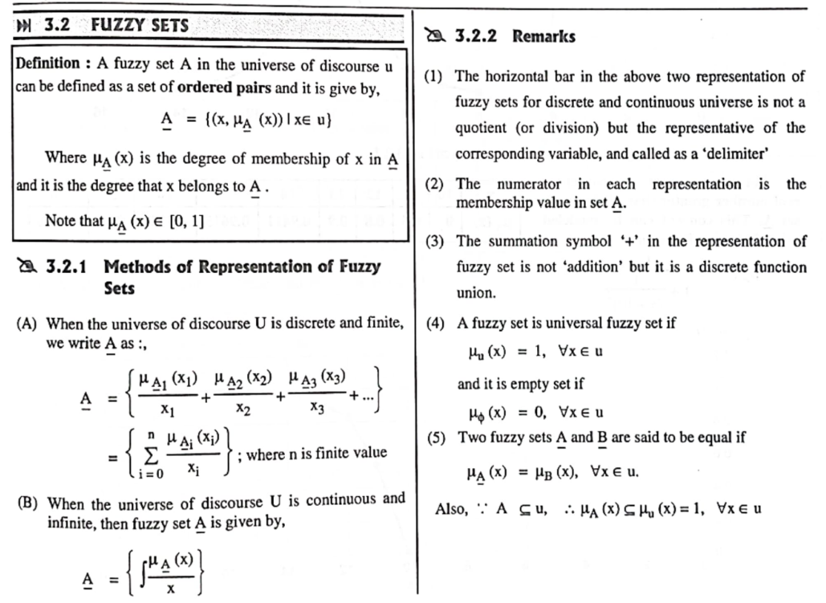

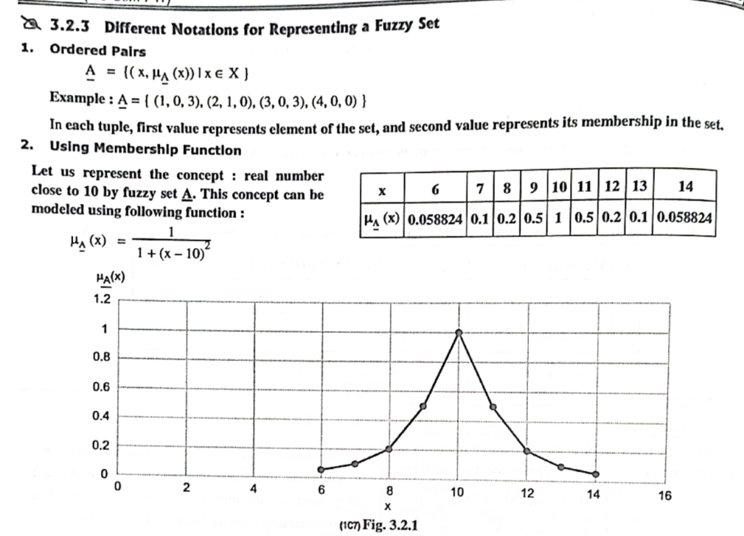

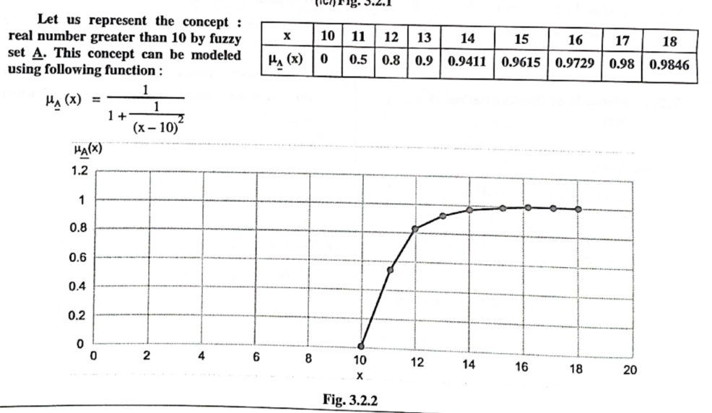

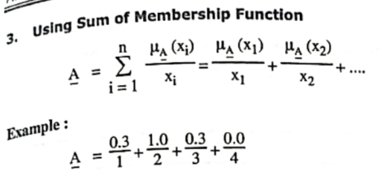

**2. Fuzzy logic & Architecture**

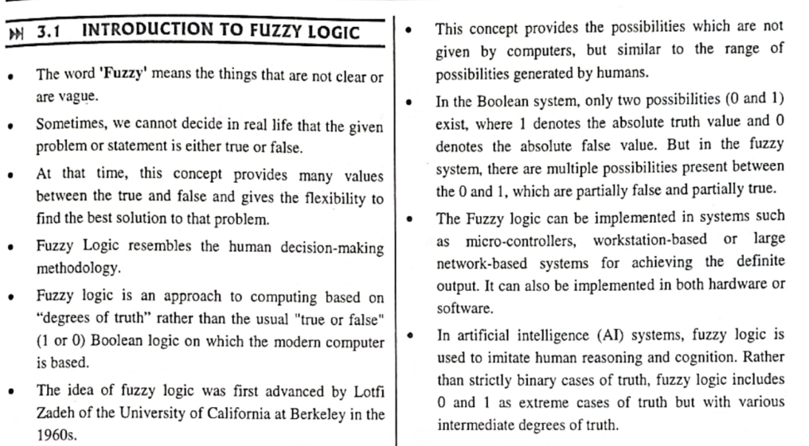

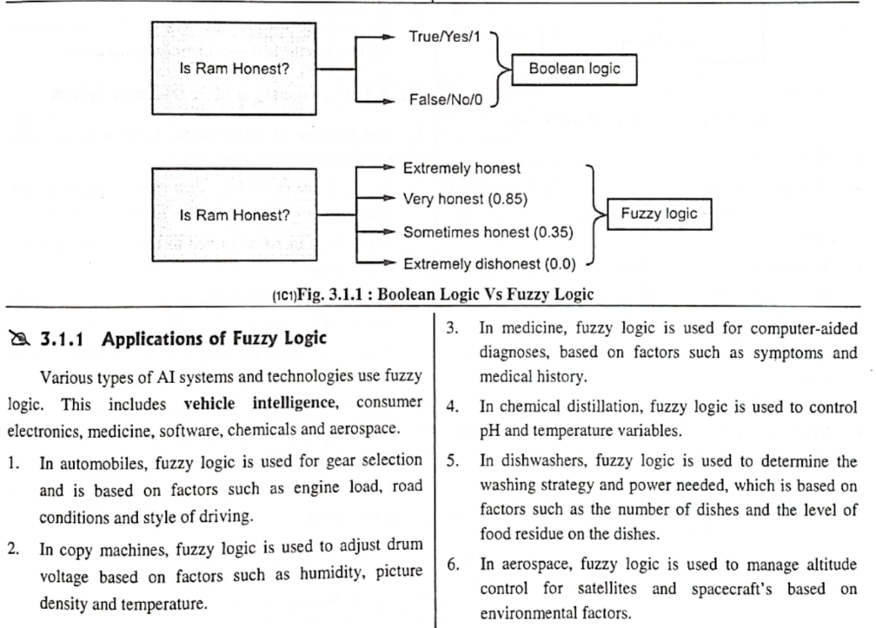

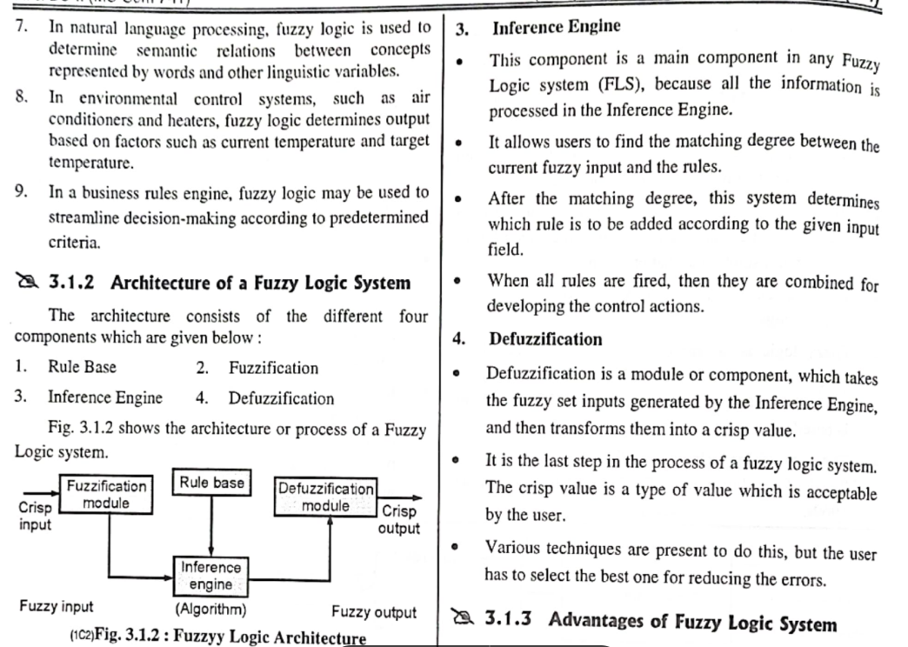

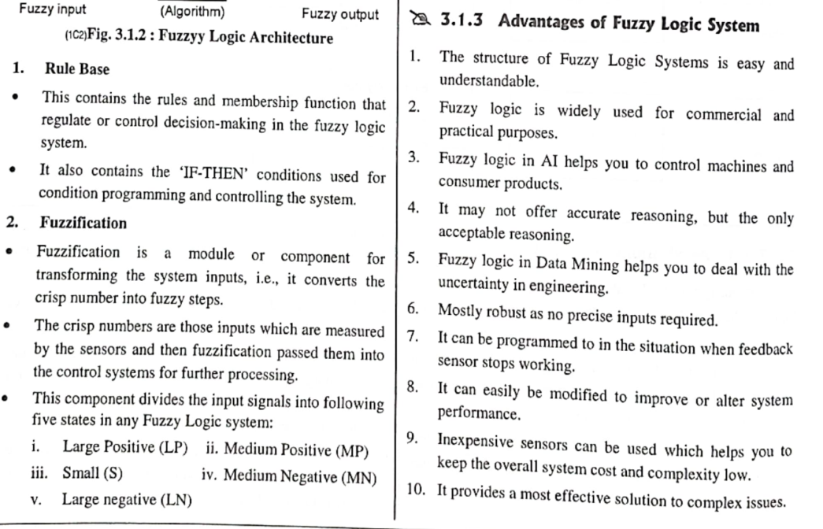

**3. Fuzzy controller - advantages, disadvantages, applications**

4. properties

5. Fuzzy set operations (union, intersection problems.) Fuzzy set relations

6. Crisp relations

7. membership functions. (no problems) formula only

**8. Comparison crisp vs fuzzy**

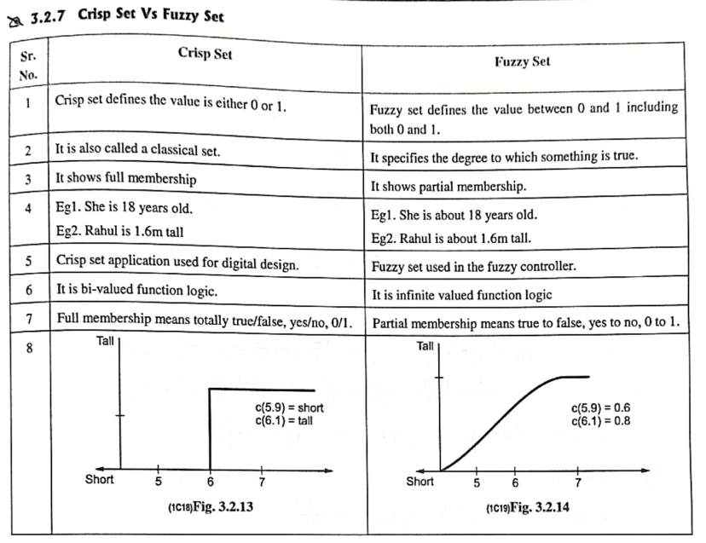

9. properties (upto 5 properties.)

10. Max min, Max product problems

11. Concept & Comparison of fuzzification and defuzzification

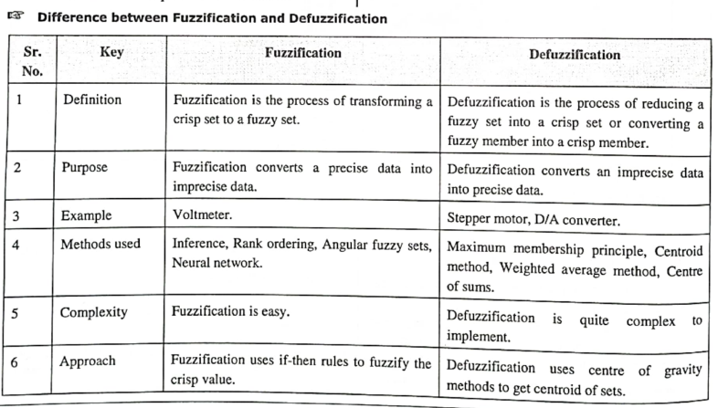

12. defuzzification method names and formula

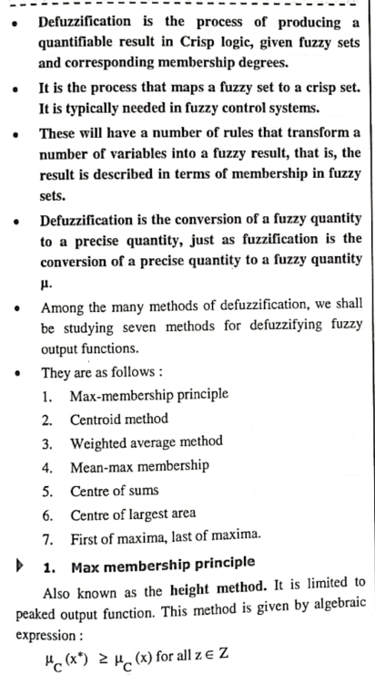

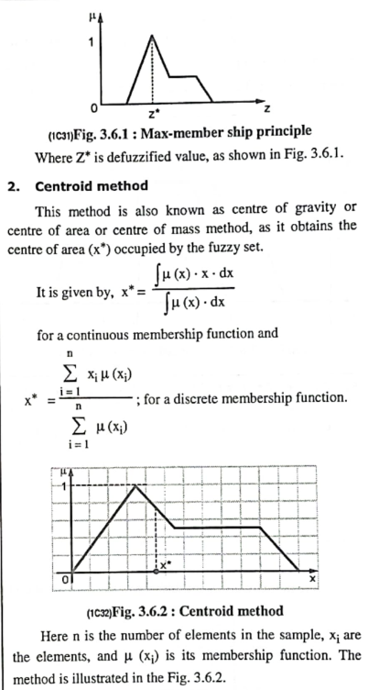

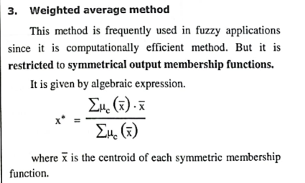

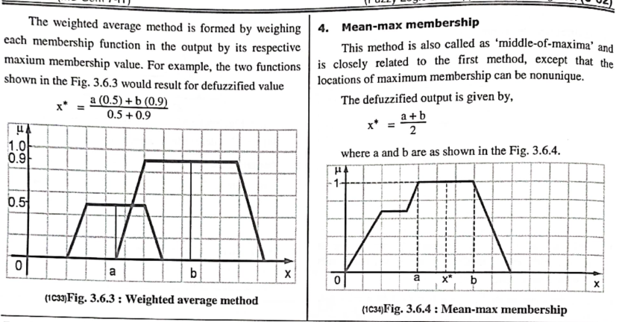

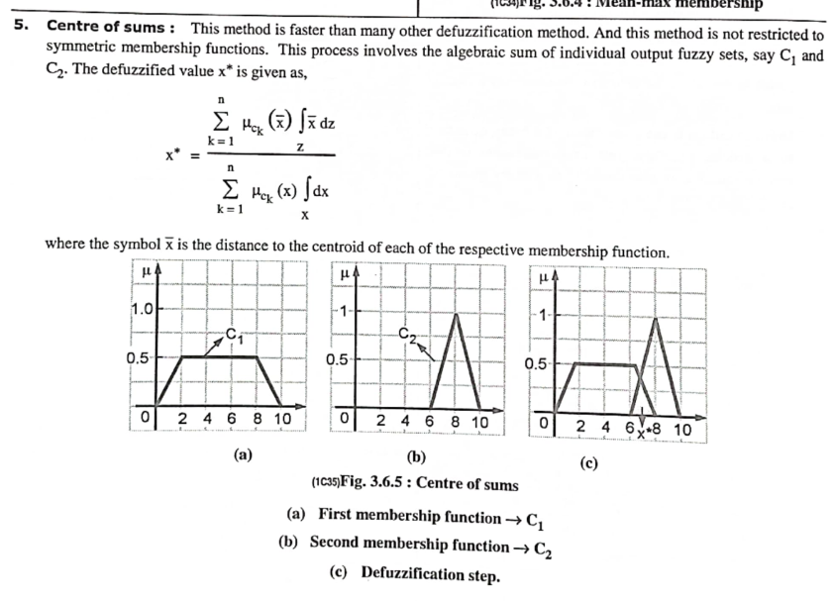

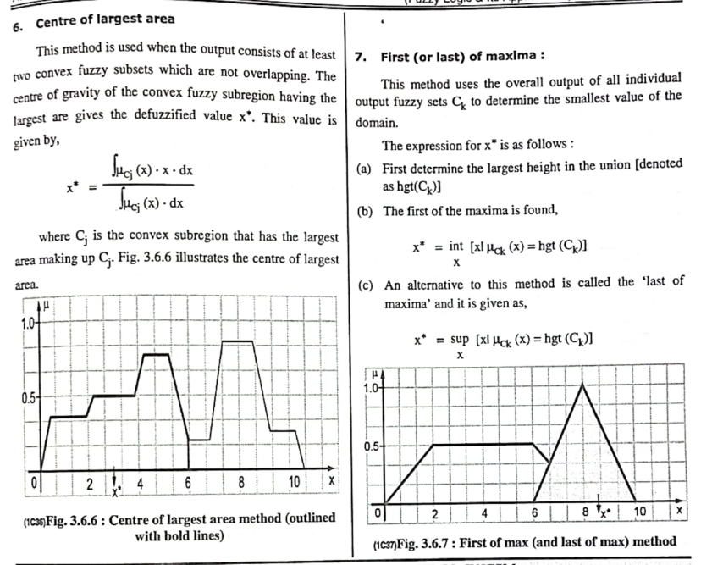

**13. Mamdani fuzzy draw diagram**

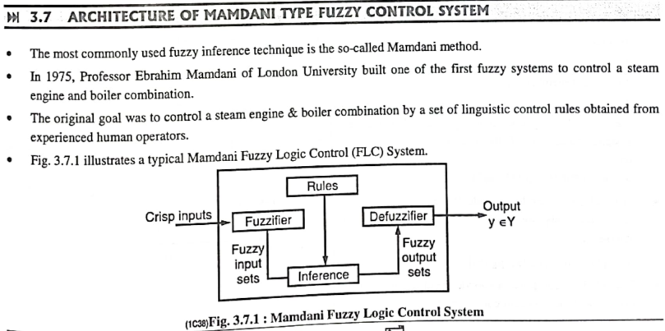

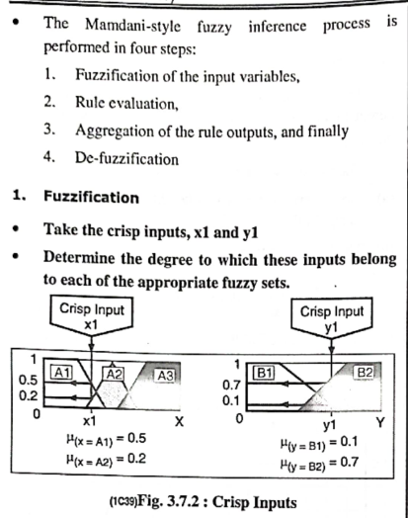

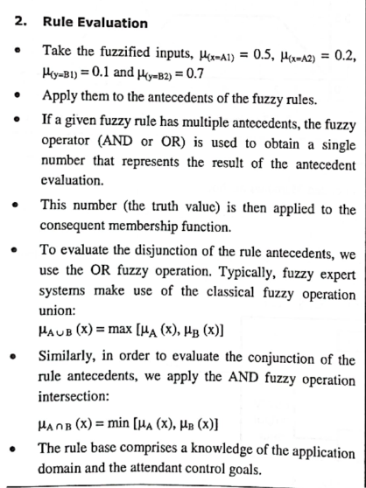

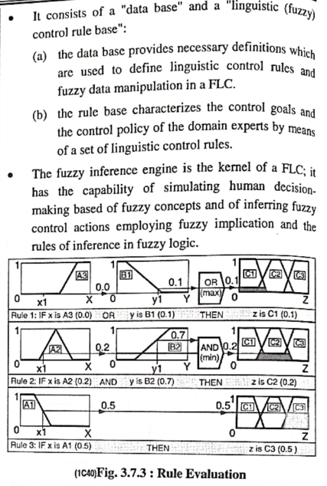

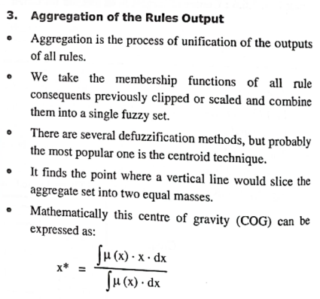

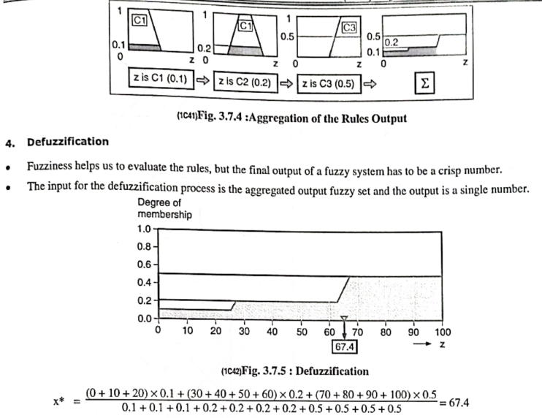

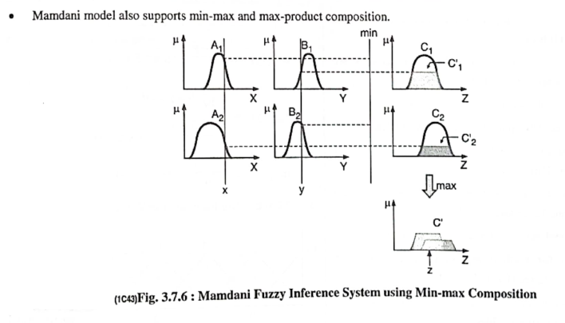

14. Washing machine problems

Module 4

Introduction to Deep Learning

Introduction to Deep Learning, ANN, Machine Learning VsDeep

Learning, Working of Deep Learning; Convolutional

Neural Network: Introduction, Components of CNN

Architecture, Properties of CNN, Architectures of CNN,

Applications of CNN, Recurrent Neural Network: Introduction,

Simple RNN, LSTM Implementation, Deep RNN,

Autoencoder: Introduction, Features, Types, Applications of

Deep Learning.

Self-learning Topics: Restricted Boltzmann Machine(RBM).

Module 5

Advanced ML Classification Techniques

Ensemble Classifiers: Introduction to Ensemble

Methods,Bagging, Boosting, Random forests, Improving

classification, accuracy of Class-Imbalanced Data.

Metrics for Evaluating Classifier Performance, Holdout

Method and Random Subsampling, Cross-Validation,

Bootstrap, Model Selection Using Statistical Tests of

Significance, Comparing Classifiers Based on Cost–Benefitand

ROC Curves.